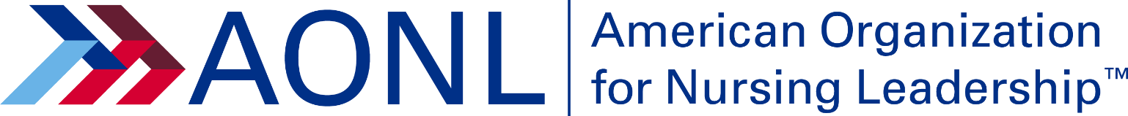

AONL Board of Directors Criteria

THREE-YEAR TERM OF OFFICE
Jan. 1, 2024 through Dec. 31, 2026

RESPONSIBILITIES
- Approving the strategic plan to meet the organization’s vision, mission and goals
- Overseeing the commitment of AONL resources
- Participate in evaluating the AONL chief executive officer
- Preparing for and attending all AONL Board of Directors meetings
- Participating effectively in Board of Directors meetings by understanding board leadership is a group responsibility and not a forum for individual achievement
- Supporting board actions publicly
- Fulfilling assignments as an AONL liaison or representative
- Participating in three two-day AHA Regional Policy Board (RPB) meetings
- Supporting the American Hospital Association Political Action Committee and AONL Foundation
- Engaging affiliate leaders in region
- Providing a virtual orientation to new affiliate presidents
- Communicating regularly with affiliate leaders
- Serving as chair/co-chair to assigned committees/task forces
- Actively mentoring and recruiting candidates for AONL national offices
- Fostering and actively promoting diversity, equity and inclusion on the board

PRINCIPLES FOR BOARD MEMBERS
- Prepare for the RPB meetings by requesting affiliate responses to the questions posed in the RPB background materials
- Connect with affiliates to understand their current issues and report out to AONL Board
- Follow up with affiliate leadership following RPB and AONL Board meetings

CRITERIA FOR NOMINATION
- Active AONL membership for past two years
- Leadership roles in an AONL affiliate or other national, state or local organization
- Participation in AONL activities (e.g. committees, task forces, annual conference, advocacy efforts, education programs)
- Holds a baccalaureate degree in nursing or advanced degree in nursing
- Letter of support from employing organization

Employment Support
Support from employing organization. Prospective candidates should get support from employing organization prior to submitting nomination application.

Minimum time commitment
Ability to make the time commitment, which at a minimum includes:
- Five days for the AONL Annual Conference
- Three 24-hour AONL Board meetings, prep time required
- Three two-day AHA RPB meetings, prep time required
- Monthly Board conference calls (two hours)
- AONL committee assignments (some meet in person and other virtually)
- Two days at Advocacy Day – Washington, D.C.
- Regional/state activities (e.g. ad-hoc speaking engagements) and other requests
Discretionary Activities
- Demonstrates collaboration and relationship-building skills
- Demonstrates a commitment to diversity, equity and inclusion
- Demonstrates understanding of AONL mission, values and issues
- Demonstrates understanding of health care, nursing and health care financing issues

Resources Available
- AONL covers expenses for AONL-related travel
- AONL provides appropriate support for AONL-related activities
- Sponsoring organization covers expenses for persons serving as an official AONL representative

REQUIRED APPLICATION INFORMATION

Completed biographical/nominations form, which includes:
- Link to LinkedIn profile
- Resume or curriculum vitae
- 100-word statement describing the biggest issue facing AONL and potential strategies to address the issue
- 100-word statement on your perspective of diversity, equity and inclusion and actions you would take to demonstrate your commitment to AONL
- 100-word statement describing the unique perspective or skills you would bring to the AONL Board
QUESTIONS
For questions about the nominations process, please contact Stacey Chappell at schappell@aha.org.

